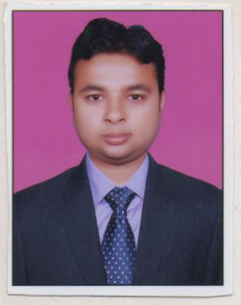
AMIT KUMAR
RZ-49, Nand Vihar
Dwarka, Sec 16 A
New Delhi-110075
Email: amit198903@gmail.com
Contact no: +919015410696

Career Objective

To work in a globally competitive environment on challenging assignments where I can utilize my current skill set and sharpen and improve them to compete with the Marketing Department requirement while constantly learning and successfully delivering solutions to problems

ACADEMIC QUALIFICATIONS

- PGDM/MBA’’ in MAREKETING & IT from ICBM-School of Business Excellence, (AICTE Approved).
- B.A. done from D.S.N P.G. College, Unnao (CSJM University) in 2010.
- Class 12th from U.P.Board in 2007.
- Class 10th from U.P.Board in 2005.
- Diploma in computer accounting

Work Experience

Current Company - Woodlam Pvt. Ltd. ( From 10th of March 2014 )
Industries - Laminate wooden flooring
Role - Business Development Executive
Job description - Meeting with Contractor / Architect / Builders, Retailers
Functional Area - Sales, Retail, Business Development, Direct sale
Responsibilities-
- Identify new sales opportunities and ensure sales achievement.
- Generating business queries, & Identify improvement areas to build customer trust.
- Maximize the visibility of brand through Promotions activity, Demonstration of kit Literature, Banners, Holding.
- Generate sales reports in the specified formats on a regular basis and keep the Project Head updated with the trends in the market.
Previous Company - Vaishno Merchandise pvt. ltd.
Duration - From 1st july 2013 to 31th Dec 2103
Industries - PVC-(pipes & fitting)/construction/ceramic /sanitary ware
Role - Marketing Executive
- Job description - Meeting with Contractor / Builders, Retailers
- Functional Area - Sales, Retail, Business Development

Industrial Experience

Summer Internship
Organization : “HCL Infosystem Ltd”, Hyderabad.
Duration : 45 days.
Title : BRAND AWARENESS” of HCL Computers with reference to HCL
Infosystem Ltd.
Activities : Selling HCL Computers in SBI branch (HAL campus)
Hyderabad on the behalf of HCL Infosystem Ltd

TECHNICAL KNOWLEDGE

- Conversant with Microsoft Office (Word, Excel & PowerPoint)
- Abilities to work on Windows (XP, Vista,7 and 8)
- Knowledge of Internet Applications

professional snapshot

- Abilities of handling Day to Day operations to stimulate growth and realize organizational objectives; capable of identifying and dealing with customers for business excellence and accomplishment of targets
- Ability to work in a multicultural environment with keen interest in learning new things.
- Hard working professional with positive attitude towards work.
- Adaptable and a quick learner, skills to work under pressure.
- Team player with strong analytical and organizational abilities.

Personal DeTAILS

Date of Birth : Dec 03, 1989
Nationality : Indian
Language Known : English and Hindi
Gender : Male
Permanent Address : H/No. 544, Chamiyani A., Unnao (209827)

DATE :-
PLACE :-
(AMIT KUMAR)

